Project 2 - Proposal

Team: Traffic Chasers

Members: Gyuheui Choi, Stan Smith, Harrison Fowler, Abdul Hussain, Zee Uzezi

The traffic chasers are interested in chasing traffic, if by “chasing” you mean figuring out where it is and how to avoid it.

Our dataset lives on the [www.Here.com](http://www.Here.com) servers. Here.com makes available a javascript-friendly API which we will query to obtain real-time traffic data, hourly historical traffic data, and historical construction data.

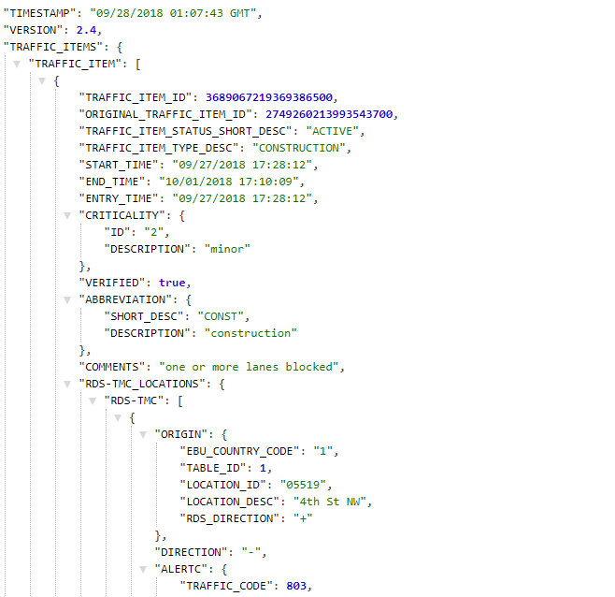

Visualization 1: An interactive map that shows the worst traffic hot spots over time from 1996 – present day. Users will be able to select any year to see worst traffic spots on the map.

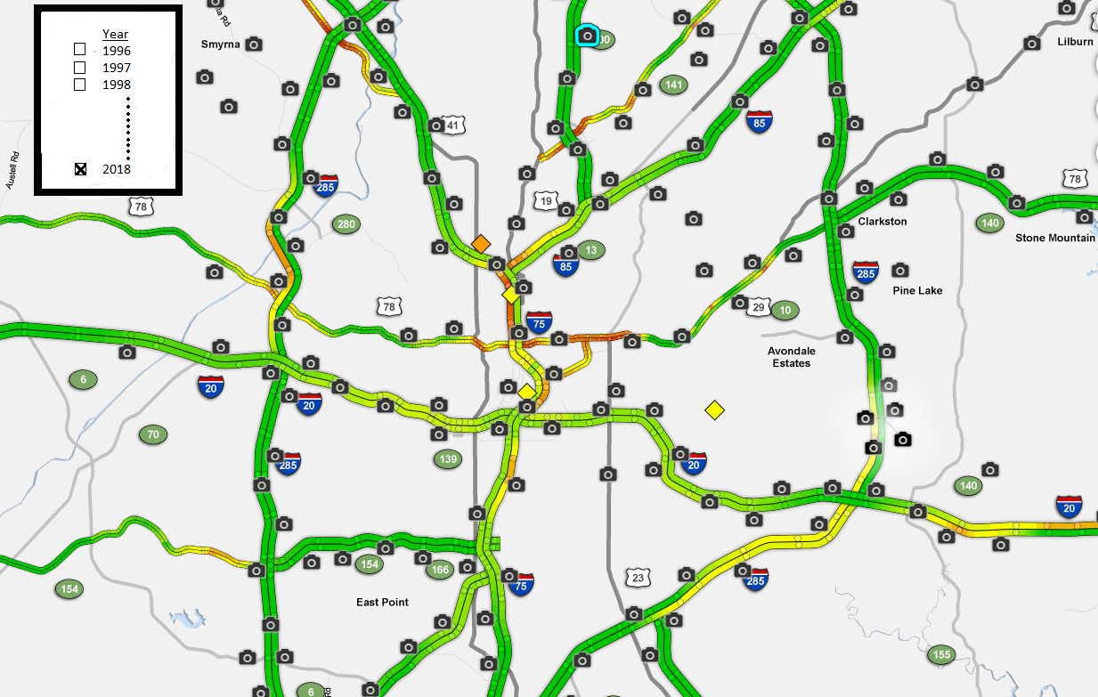

Visualization 2: an interactive map that uses data from the last 365 days to show the worst traffic spots by hour of the day. User will be able to select the hour of day.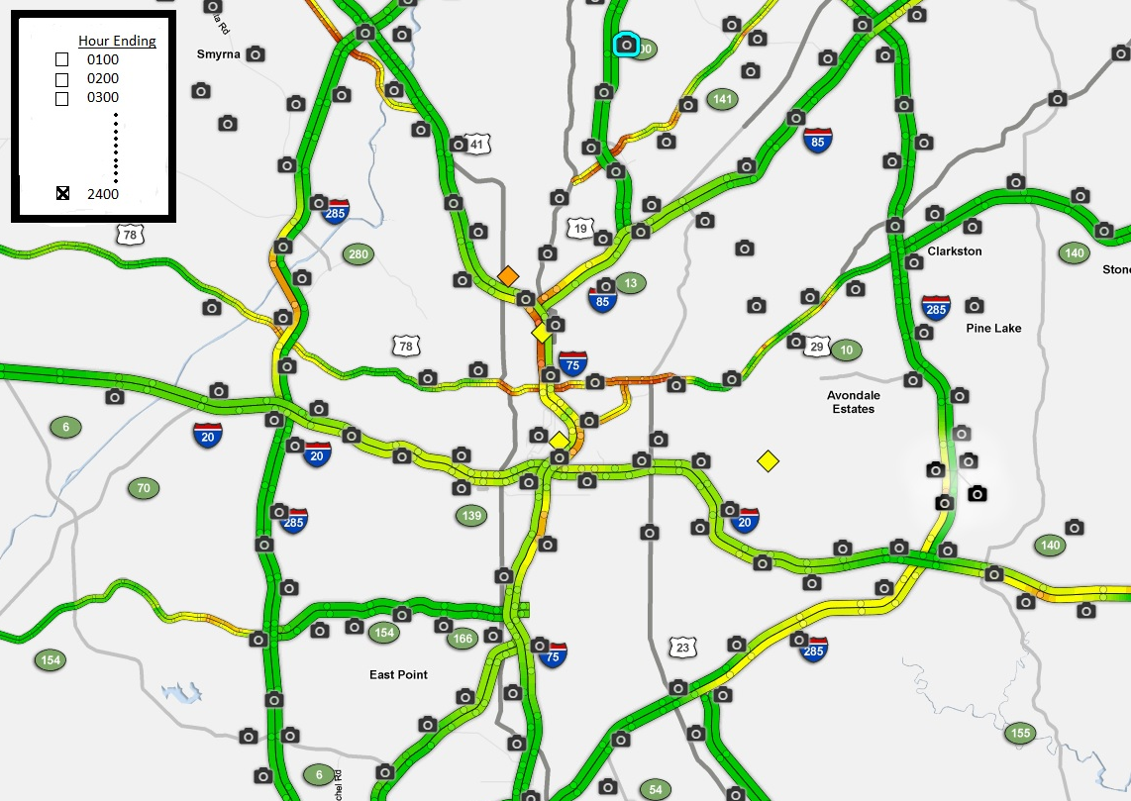

Visualization 3: a map that allows users to select a construction site and see it effect both (positive and negative) on travels time using related roads. It will look something akin to the following:

